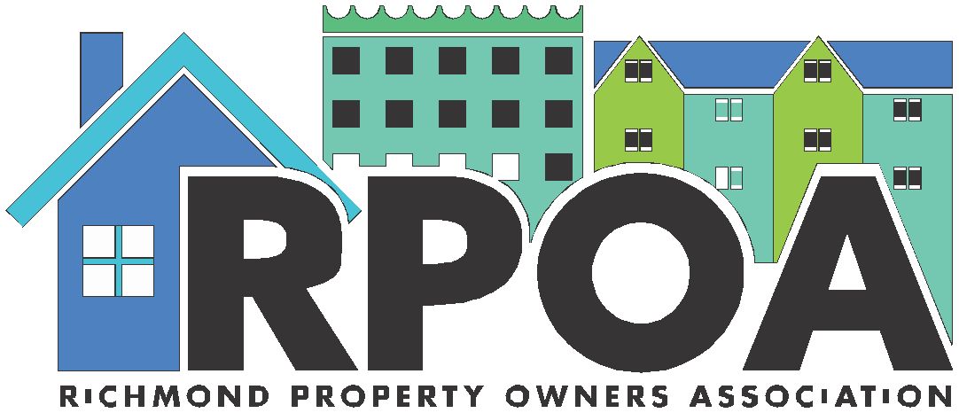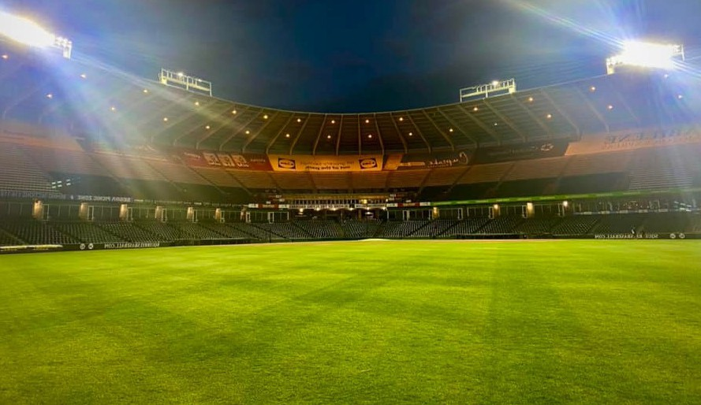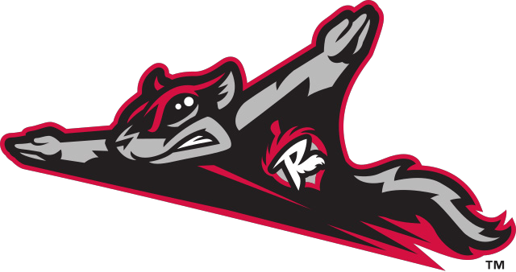

Fan District Night
at The Diamond
Tuesday June 20, 6:30pm

The Diamond - 3001 N. Arthur Ashe Blvd., Richmond, VA 23230

You’re invited to join RPOA members at The Diamond on Tuesday June 20 for a fun evening cheering on the Richmond Flying Squirrels vs. Harrisburg Senators!
Bring family, a friend or fellow real estate investor and spend Tuesday evening at the ballpark!We have up to 150 tickets that RPOA has purchased for members and their guests. Gates open at 5:30 with First Pitch at 6:35 PM.
Please register ahead of time so we know how many are coming. Once you have registered, your tickets will be under RPOA at the "Will Call".
Thank you, and we look forward to seeing you there!

Register at richmondpropertyowners.com

